Stage 1 – Blue Team Shooting Sports Practice Stage
COURSE DESIGNER: Ike Starnes
SCORING: Comstock 12 rounds.
TARGETS: 6 cardboard targets
SCORED HITS: 2 Best hits per carboard will be scored.
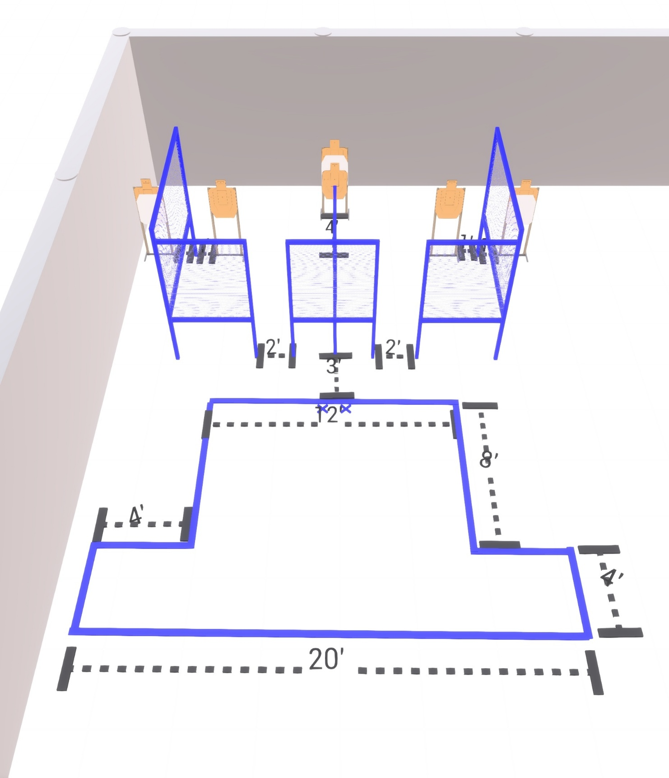

Written Stage Briefing:

Stage 1 – Blue Team Shooting Sports Practice Stage - is a 12 round, 60 point, Comstock Course. There are 6 cardboard targets.

Starting with both feet on the Shooting Sports Innovations Xs.
Handgun is loaded and holstered, wrists below belt.
PCC is loaded held in both hands, stock on belt.

On the audible start signal, engage targets from within the shooting area.

USPSA / NROI Range Commands:
- Make Ready
- Are you ready?
- Standby
- If finished, unload and show clear
- If clear, hammer down and holster (Handgun)
If clear, hammer down and flag (PCC)
If clear, cylinder closed and holster (Revolver)
- Range is clear

Setup Notes:
8 Single Wall Stands
2 Double Wall Stands
2 Full Walls
4 Half Walls
5 Target stands / 10 target sticks
1 Starting Xs
